# Screenshots for Project 3

## Data Tables from PyCharm (MLB Players)

## Postman – GET all players

API Endpoint of **localhost:5000/api/v1/players** with a **GET** request.

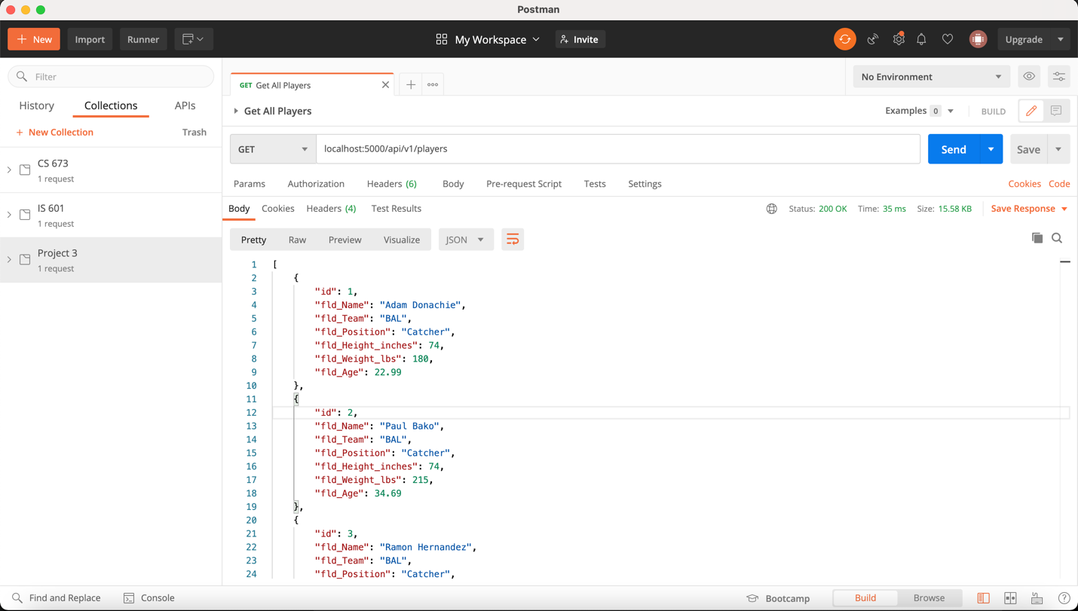

## Postman – GET player by Id

API Endpoint of **localhost:5000/api/v1/player/:id** with a **GET** request.

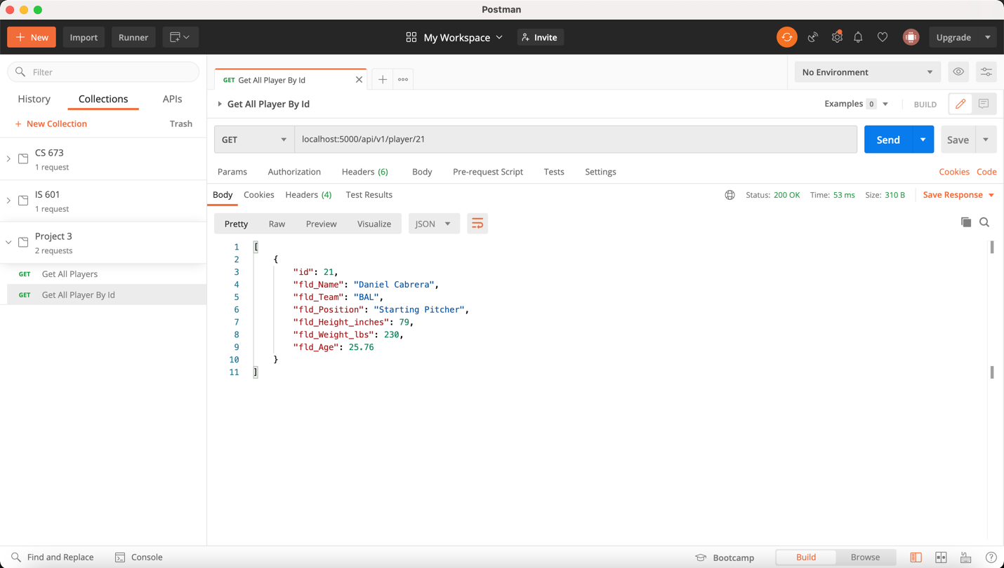

## Postman – POST a new player

API Endpoint of **localhost:5000/api/v1/player** with a **POST** request with a JSON body containing new player data shown below.

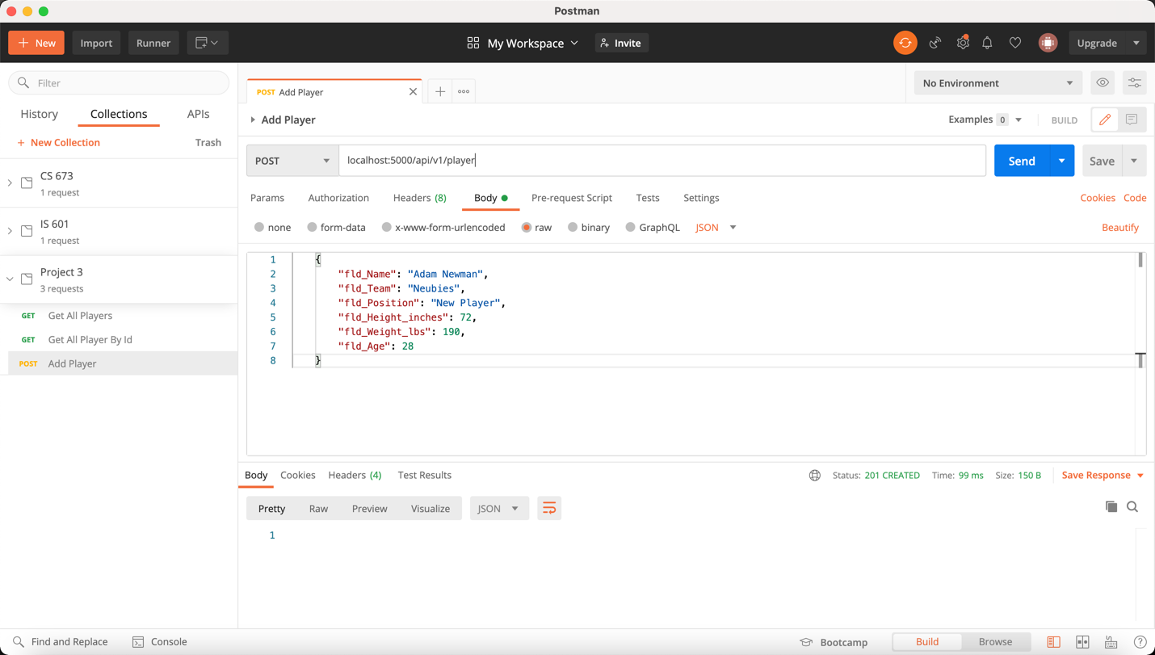

Note that we can query for all players again and see that the new player was added below. Also note that the player id is 101 since the database will automatically increment the primary key.

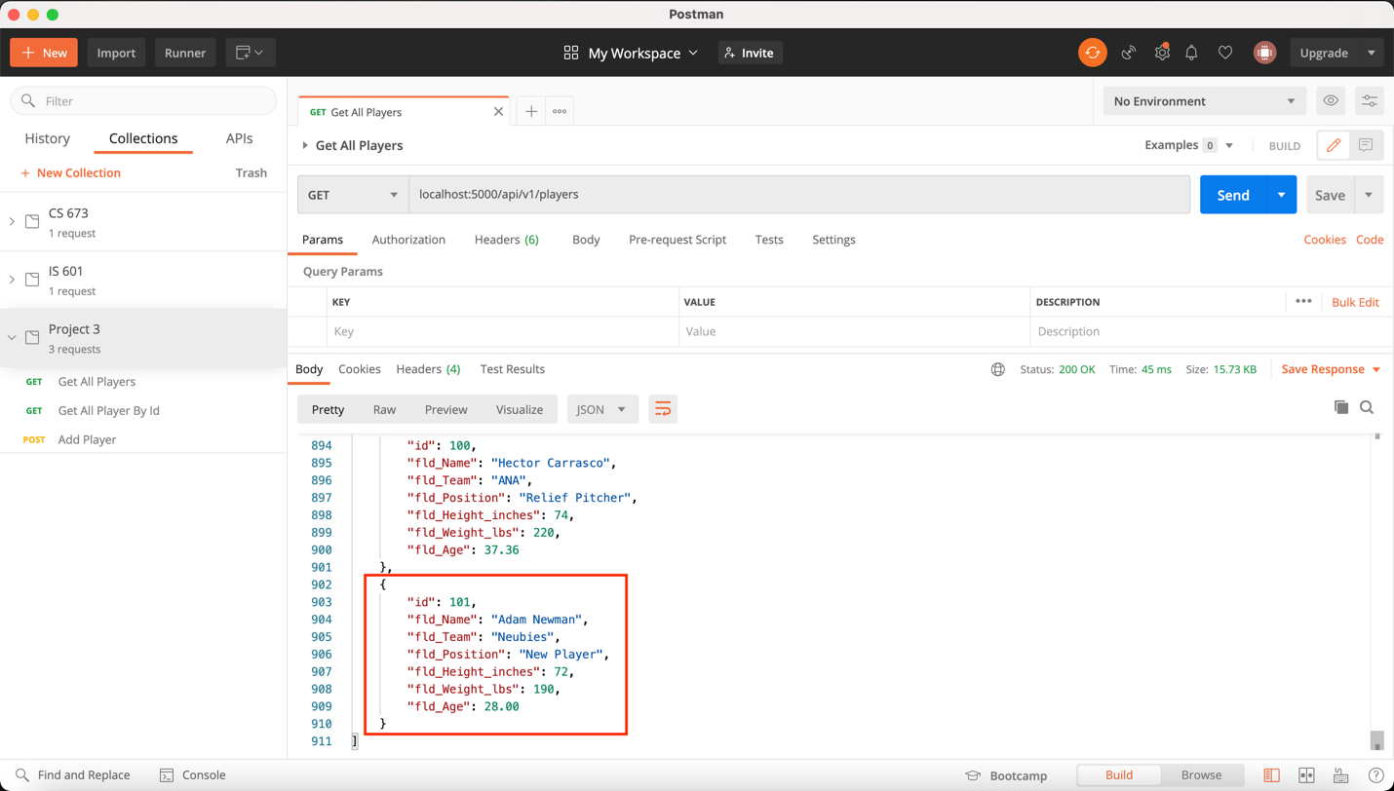

## Postman – PUT request to update existing player

API Endpoint of **localhost:5000/api/v1/player/:id** with a **PUT** request containing the JSON body payload below. The fields inside the red box were changed.

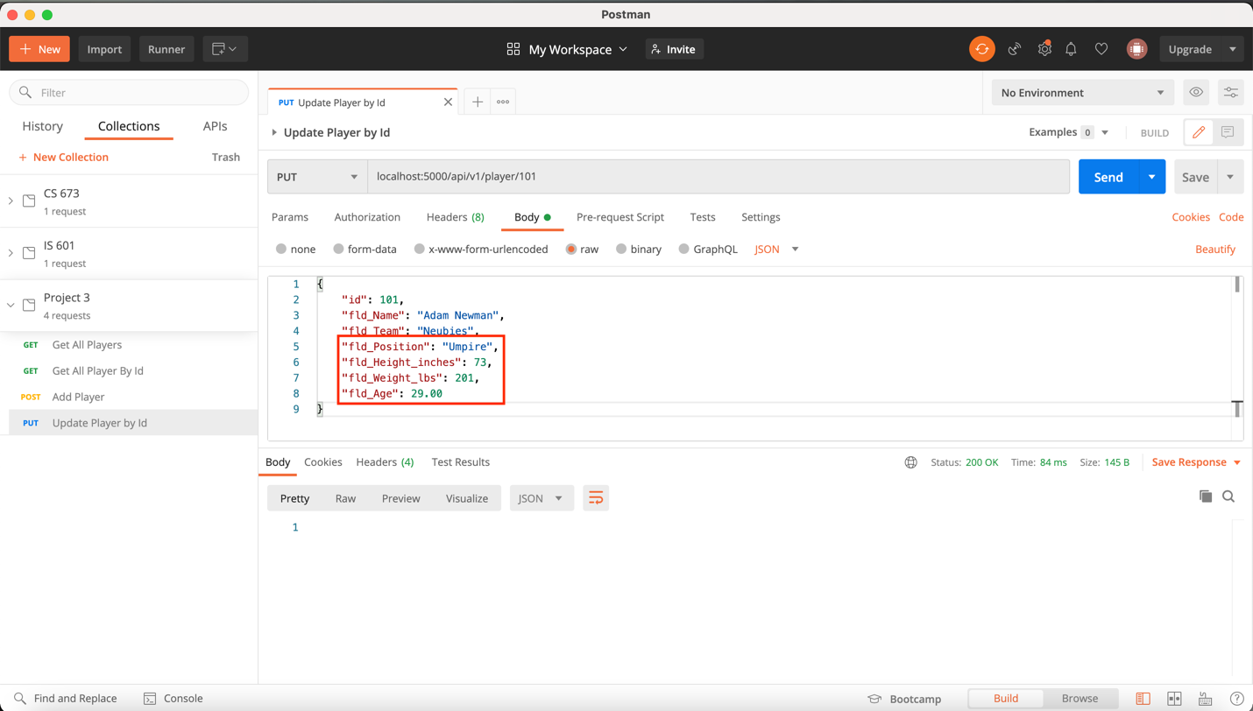

Now we can **GET** query for the player by id and see that the existing player indeed updated.

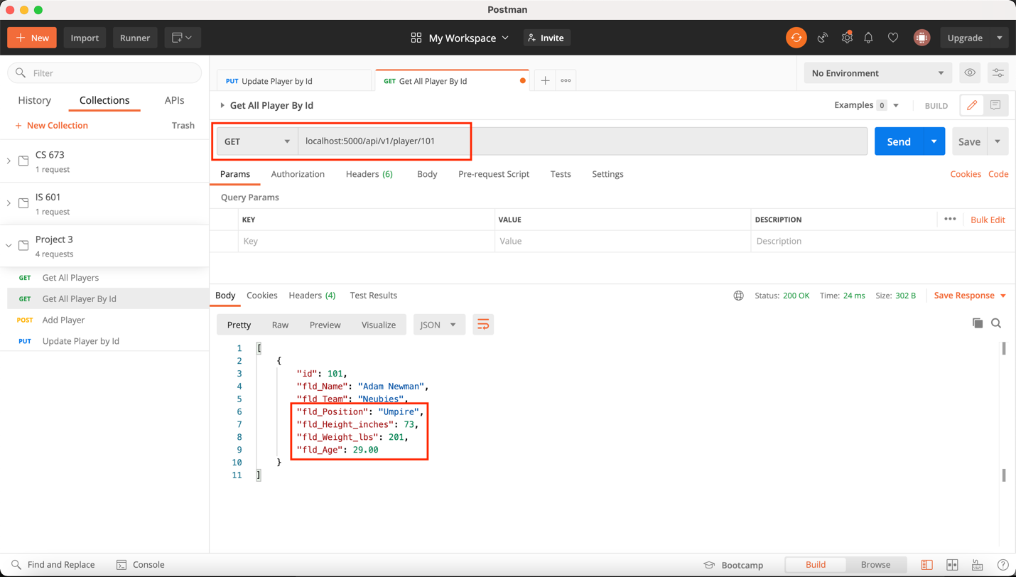

## Postman – DELETE request to remove an existing player

API Endpoint of **localhost:5000/api/v1/player/:id** with a **DELETE** request containing the JSON body payload below. The fields inside the red box were changed.

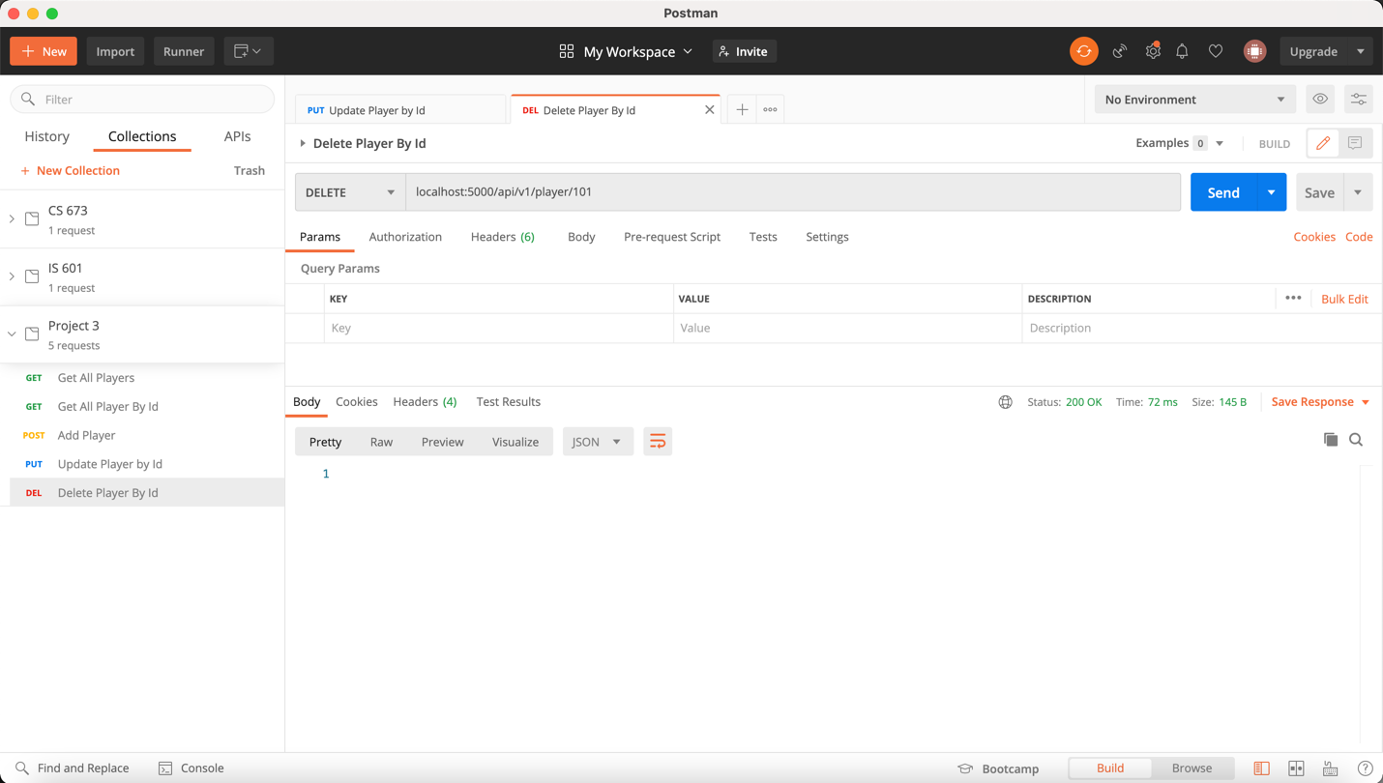

Note that we can query for the player by id again and see that the player no longer exists.

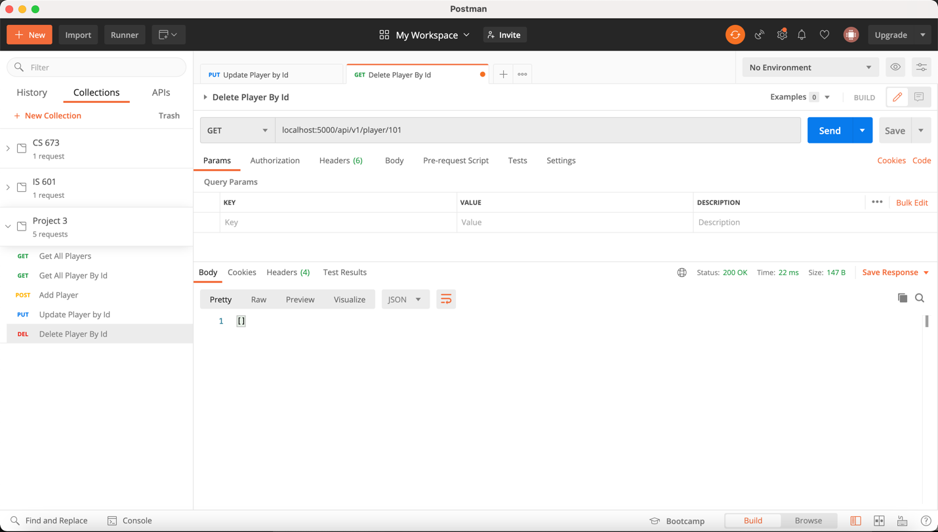

# Screenshots from Homework 5 (Jinja Templates)

## Home Page for All Players



## View of One Player Record



## Add a New Player Record





## Update an Existing Player Record



## Delete an Existing Player Record

